I am MR Stelios Hatjichristofis, Orthopaedic Surgeon. I spent 25 years in Johannesburg in South Africa where I did my specialty and my thesis in Orthopedics at one of the best medical schools in the world at the time - Medical school of University of the Witwatersrand . These many difficult exams and difficult dissertation along with the very difficult and demanding training in academic hospitals made the foundations for high quality orthopaedic Surgeons. After the acquisition of an extremely difficult specialty I was a Consultant and head of the Orthopedic Department of the knee and Arthroscopy in the Academic Hospital of the University of the Witwatersrand Johannesburg General Hospital) where I worked for the following 5 years. In these years I perfected my skills in Trauma, in Arthroscopy, in Arthroplasty and foot and hand Surgery. I will have to mention that I did my initial degree in Sofia, Bulgaria where I learnt the language and I studied Russian language for three years. I can read the Cyrillic (Kirill) alphabet and even though I cannot speak the language well, I can recognize a lot of words especially the medical ones. I can speak fluent Greek and English. I will have to add that I wrote the Greek exams for basic degree and Orthopedic degree for recognition in Greece.
After I completed about 13 years in the Academic Hospitals as Registrar and Consultant, I went to the private sector where I worked for 12 years at two Private hospitals, one of the largest hospitals in Africa. Along with my specialty training and my thesis I did follow all developments and progress in orthopedics, I got diploma in ATLS (Advanced Trauma Life Support), I got a diploma for Research in Medicine, got a diploma in Robotic knee arthroplasty and I did knee replacements with robotic techniques for 8 years. I followed all the developments in arthroplasty, arthroscopy and surgery of the knee, shoulder, Hip, elbow, hand and foot. The private hospital was tertiary referral center and got referrals from all over Africa. I had a very successful career in private medical practice in Johannesburg. All those years I stayed in touch with modern Orthopedic Medicine with two to three international conferences a year and two to three orthopaedic workshops for training and specialization in new methods and instruments. At the same time, I was teaching at the medical school of the University of the Witwatersrand medical students and Orthopaedic Registrars.
For 5 years now, I am back to Cyprus where I work at Apollonion Hospital, in Nicosia and I offer the experience and my skills to the public. I'm proud of the very difficult and high level of specialist degree, that I've picked up in South Africa. By the time I'm in Cyprus have done extremely difficult cases with great success. I wish that this become known to everybody in Cyprus. I can help in decisions making about the preferred treatment within the latest developments and also in performing difficult surgery. Some of the cases that I did surgery upon were permitted to go overseas for treatment on government expenses. Besides the experience and skills that I bring from my long-term stay abroad I continue to remain close to the developments of modern Orthopaedics with international conferences and workshops for new methods in America and in Europe. I have already bring the new Custom made implant – Knee Arthroplasty with a prerequisite an MRI and special x-rays of the lower limbs that the X-ray department of the Apollonion is fully prepared to do that. It will take only 6 weeks for ordering the instruments from Switzerland.
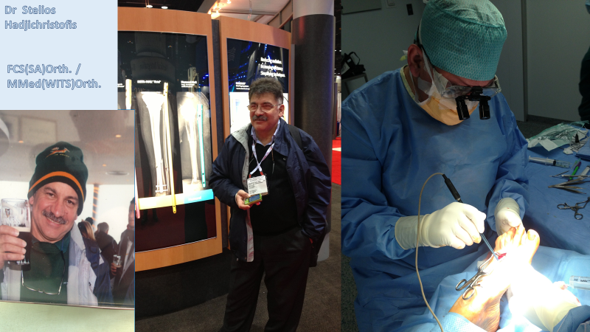
I can offer you high quality services with honesty. You will get advice that will be at high level comparing anywhere in the world. Medicine in Cyprus has become very difficult issue due to the large "Marketing" of miracle cures and new methods that no one else can perform!! There is a great confusion. Medicine is a science of logic using the correct knowledge. Logical thinking based on correct information. I can help.
====================================================================================

Mr Stelios Hadjichristofis FCS(SA)Orth. / MMed(WITS)Orth.

ORTHOPAEDIC SURGEON – Trauma, Sport Trauma, Arthroplasty, Arthroscopy,Hand & Foot surgery

Fellow of the College of Medicine of South Africa - FCS(SA)Orth.

Master of Medicine in Orthopaedics – University of Witwatersrand - MMed(WITS)Orth.

Member of the South African Orthopaedic Association

Affiliate Member of the American Academy of Orthopaedic Surgeons

Member of ESSKA (European Society of Sports Traumatology Knee surgery and Arthroscopy)

Member of ISAKOS(International Society of Arthroscopy, Knee Surgery and Orthopaedic sports Medicine)

Holder of the Greek Orthopaedic Exams – Athens

Senior Lecturer at the University of Witwatersrand Medical school - Johannesburg
e-mail: hadjichristofis.stelios@cytanet.com.cy
cell: 00357 99722555 web: http://orthodoc.aaos.org/Hadjichristofis/
Phone: 22469089 / 092 www.bonejointcyprus.com

